

**Some Current Issues in UK Monetary Policy**

Speech given by

Timothy Besley, Member of the Monetary Policy Committee, Bank of England

UBS Conference centre, London 28 October 2008

I would like to thank Neil Meads, Paolo Surico and other colleagues for comments. The views expressed are my own and do not necessarily reflect those of the Bank of England or other members of the Monetary Policy Committee.

1

All speeches are available online at [www.bankofengland.co.uk/publications/Pages/speeches/default.aspx](http://www.bankofengland.co.uk/publications/Pages/speeches/default.aspx)

Ladies and Gentleman, thank you for coming. I should begin by saying how grateful I am to UBS for organizing this speaking engagement.

I don’t need to remind you all that these are challenging times for economic policy. We meet here today against a backdrop of anxiety about economic prospects here in the U.K. and around the world. Recent rises in energy and food prices have squeezed real take home pay over the past year and pushed annual CPI inflation to 5.2%. At the same time, the economy is weakening with the initial third-quarter estimate of GDP growth in the U.K. at -0.5%.

The evolving issues in the financial sector, described rather colourfully by ex- Chairman Greenspan last week as a financial tsunami, have lead to a series of major policy initiatives around the world. Many of these were unimaginable a year ago.

Against this backdrop, the MPC is in the process of putting together its forecasts for the November Inflation Report. This will allow us to take stock of these events as best we can and to reach our best collective judgement on the outlook for the U.K. economy. In the present climate, this task will prove unusually challenging.

I want to use this opportunity to share with you a few thoughts on where we have been and where we might be going. I also want to discuss the role of monetary policy in the current economic climate given conditions in financial markets.

I still believe, as I have for a number of months, that we should think of the current events as a period of significant rebalancing for the U.K. economy. Ultimately, this process will lead us towards an economy which is somewhat less dependent on financial services than was the case in early part of this decade. It would be better were such rebalancing to take place against the backdrop of a robust global economy. However, the global credit shock that we are experiencing is accelerating the pace of this adjustment at the same time as weighing down on global demand more generally. There is much uncertainty about the path that the economy will now take and how severe and prolonged the decline in living standards will be.

The forces that have shaped long-run prosperity in the U.K. — skills, infrastructure, openness, economic freedoms and a framework for intelligent economic policy making — remain in place. Given that we have been accustomed to economic stability for some while now, the anxiety level is high. As ever, our national character will show through in the way that we respond to the needs of those who are particularly hard hit by the economic downturn.

Let me begin with some reflections on how we arrived where we are today. If we look back at the period since the turn of the Millennium, it does not look like a classic economic boom – inflation has stayed close to the target set for the MPC by the Chancellor. Economic growth has been stable and robust, but at a level which is not exceptional by post-war standards. This is illustrated in Chart 1.

But beneath this benign picture — also referred to as the Great Stability — some imbalances were accumulating, the consequences of which have become increasingly evident in recent months.

The first of these imbalances has been the growth of household indebtedness with the concomitant rise in house prices. Chart 2 shows the well-known story on house prices. The movement since 2001 is particularly striking. This period also saw a dramatic rise in the household debt to income ratio as shown in Chart 3. This was part of a more general increase in credit availability for which Chart 4 on M4 lending provides a good illustration.

As this imbalance unwinds, we are now seeing a sharp contraction in credit availability accompanied by a fall in house prices. Just how far this has to run remains unclear. However, it is unlikely that terms of access to mortgage credit will move back to where it was in early 2007 for some time, if ever.

Another significant imbalance has been in terms of the balance of payments. Since around 1999, the U.K. has been running a significant current account deficit as illustrated in Chart 5. A deficit such as this is sustainable only as long as the U.K. is able to sell assets to the rest of the world. And over this period, the U.K. has been a

beneficiary of capital inflows in significant measure from the emerging market economies. It is this capital account surplus which links the current account deficit to developments in the housing market. The household savings rate in the U.K. has been low and falling as shown in Chart 6. In this context, the U.K. was able to benefit from overseas finance to support our housing market by selling mortgage-backed securities to investors abroad, supporting rapid growth in RMBS issuance as shown in Chart 7.

The unwinding of this imbalance is part of the reason why sterling has been weak in the period since August 2007 as shown in Chart 8. One of the factors behind the fall in the pound is surely the fact that foreign investors are now demanding a higher risk premium to hold U.K. assets. In fact, as noted in the Financial Stability Report (page

13) — a Bank of England publication released today, demand for U.K. mortgage backed securities has all but disappeared.

The continued weakness in Sterling will tend to push up on inflation as it passes through the economy. Part of the reason why inflation has risen so sharply in the past year has been the rapid pass through of import prices with import price inflation currently running at 11.4%, the highest level since 1985. Sterling weakness will also lead to a further squeeze in real living standards as UK consumers will, in the end, have to pay more for imported goods. However, there is silver lining, since it does provide a more positive outlook for exporters and import competing firms (other things being equal) and, in time, this will assist in rebalancing the economy.

As a consequence of events in financial markets, we now face the continued risk of a significant contraction in the availability of credit to households and businesses. This will be particularly striking relative to the period immediately prior to August 2007 in which credit was in plentiful supply on attractive terms. Looking ahead, businesses who find themselves renegotiating financing deals that were initially struck before August 2007 may be particularly hard hit.

One popular chart for looking at the global credit crunch is the three-month Libor-OIS spread in Dollars, Euros and Sterling. Over the past year, it has become a standard Chart in the presentations that I have given to business audiences and I reproduce it in

Chart 9. As this Chart shows, these spreads rose dramatically after August 2007 and have remained high over the period since. During September and October this year, these rates rose once again to even higher levels.

These charts provide an indicator of the market-determined price of credit in a particular market. For a number of businesses, lending is directly linked to 3-month Libor. However, as with any single indicator of general credit conditions in the economy, it should only be viewed as indicative. One thing that does not come out from looking at this Chart is the fact that the maturity of lending in the interbank market was moving more and more towards shorter maturities with banks becoming increasingly reliant on borrowing at the shorter end of the yield curve. In effect, banks were themselves becoming credit rationed.

The events of recent weeks have revealed vulnerabilities in the financial sector that are more severe than was first apparent. And this has taken most market participants and commentators by surprise. Markets have consistently been predicting a gradual unwinding of the credit crunch with falls in Libor-OIS spreads towards more normal levels. Chart 10 illustrates this by looking at market expectations at the turn of the year.

As discussed at length by the Governor in his recent speech in Leeds, the problem of inter-bank funding worsened in September and early October, when it became clear that provision of liquidity to alleviate these problems was not dealing with the core problems of lack of capital in a number of UK banks. This recognition led ultimately to the government’s policy response in the form of the bank recapitalization plan launched on 8 October. On the same day as this was announced, the MPC joined in a coordinated action with other leading central banks and lowered Bank Rate by 50bps. As you will have seen, support among the MPC for this action was unanimous.

There is now a widespread recognition that a variety of policy responses is necessary to deal with these global problems. In addition to interventions targeted at the problems in financial markets, fiscal policy also has a role to play in supporting the process of adjustment.

Since 8 October, many forward-looking indicators of economic activity have moved further to the downside suggesting that activity in the U.K. economy is set to weaken further. The MPC had for some time been balancing upside risks to inflation from shocks to commodity and energy prices against downside risks to inflation from the weakening of real activity associated with the credit crunch. As you will know, there was a time last summer when I judged the upside inflationary risks to be sufficient to warrant an increase in Bank Rate to head off the prospect of persistent inflation. But since then, the sharp fall in commodity prices and the consequently more benign prospects for food and services inflation, as well as the substantial weakening in demand, imply that the upside risks to inflation have diminished significantly.

Conditions in credit markets are likely to remain tight ahead of the full effects of recent government initiatives working their way through to the terms faced by borrowers. It is now less likely that the rebalancing process for the U.K. will be as gentle as thought one year ago.

Before assessing the implications of this for monetary policy, I want to make a few comments on the prospects for consumption in the U.K. economy. Given that consumption accounts for around 70 per cent of national spending, the prospects for consumption will have a material impact on the path of economy in the coming months. I will use this discussion also to comment on one aspect of the way that the monetary transmission mechanism is currently working, i.e. the way in which the level of Bank Rate affects the economy in the current economic climate.

As I have already remarked, the period prior to the current turmoil was not characterized by exceptionally strong consumption growth. However, to mirror the developments in house-price inflation that I discussed above, the share of household spending devoted to housing did show a pronounced increase according to data from the expenditure and food survey in Chart 11. The blue line in Chart 11 illustrates how those with mortgages were spending a larger fraction of their incomes on housing.

Thus, even though mortgage interest rates were low by historical standards, house price increases required households to spend a larger fraction of their incomes on housing. This is one of the reasons why inflationary pressures remained muted for

non-housing goods over this period in spite of increased availability of household credit. The ONS data for the consumption of housing services are represented by the line in pink. This shows that the consumption of housing services was not rising anything like as fast as housing expenditure over the same period.

One consequence of the recent falls in house prices is that we should, over time, expect to see households devoting a smaller fraction of their expenditures to housing. Indeed, the next generation of home owners will benefit from lower house prices.

However, this will take some time to be reflected in data at the macro level.

More generally, there are good reasons to believe that consumption growth will be weak in the near term. The fundamental drivers of consumption include the prospects for growth in real incomes – not just in the short run but also over the longer term.

The former are clearly weaker and are definitely more uncertain. The recent welcomed fall in commodity and energy prices, if it is sustained, will however support some growth in real incomes going forward.

But access to credit is also a crucial determinant of consumption and is likely to be a significant determinant of consumer behaviour in the next year or so. There are a range of indicators which show that access to credit has become more difficult. But in general this is poorly captured by looking solely at indicators of the price of credit.

For those who can borrow to buy housing, rates are not exceptionally high, especially by historical standards as shown in Chart 12. Indeed, on conventional measures we have seen a significant fall in real interest rates over the past year.

Much more relevant, however, is the availability of credit. In the mortgage market, many borrowers, especially those requiring high loan to value ratios, are effectively rationed out of the market. This is unlikely to end until house prices stabilize and first time buyers have accumulated sufficiently large initial deposits to reflect greater caution on the part of lenders. The latter is likely to come mostly from increased saving.

But this is not the only factor that is likely to increase saving. During the period of rising house prices, home owners with equity were able to draw on this in times of need. Bank calculations on the rate of mortgage equity withdrawal suggest that this was indeed the case as illustrated in Chart 13.

There are good reasons to think that lenders will be more reluctant to support such behaviour for many borrowers going forward as the value of housing collateral falls. This may also weigh down on consumption growth since prudent consumers will find it more necessary to hold larger levels of savings as a cushion against unforeseen events.

Through both of these channels, household indebtedness is likely to moderate and saving to increase, other things equal. This, alongside weaker prospects for real income growth, is likely to weigh down on the growth of demand in the near term, and possibly beyond.

There is much discussion right now about the right level of interest rates in the current situation and the likely impact of cuts in Bank Rate on the economy. As long as credit availability is limited and the adjustment that I have just described is underway, I would not expect consumption to be particularly responsive to the level of interest rates. What matters is that the policies directed towards restoring more normal conditions in credit markets are effective. Given time to work, these should also lead to households and businesses feeling more confident about spending and investing.

It is essential in the current climate, as ever, for the right policy instrument to be used for the right purpose. A cut in Bank Rate, on its own, will not be a magic bullet. No single instrument can work to achieve all goals. One of the U.K.’s greatest policy economists, James Meade, formulated the proposition that the art of good policy- making involves using appropriate policy instruments targeted at the right objectives. It remains correct, in my view, that monetary policy should remain focused on achieving the 2 per cent inflation target in the medium term.

Monetary policy can play a role in conjunction with other policy responses to meet the current challenges. The plan announced three weeks ago to recapitalize UK banks is a key policy measure as have been the extended liquidity operations of the Bank of England over the past year or so. Judgements on the right level of rates have to be made in the context of the wider outlook for the effectiveness of monetary policy and the way that other policy measures are having an impact on the economy.

Right now, all three of the conventional channels for the transmission of cuts in Bank Rate on to the real economy are impaired. I have already discussed the context for consumers where credit availability and an adjustment in the savings ratio are the real story. Monetary policy also has an effect on financial conditions faced by businesses, who frequently borrow using products that are linked to Libor. As we noted above, the 3-month Libor remains well above Bank Rate. Some banks also seem to be seeking to widen the margins that they charge over an already elevated 3-month Libor rate. The MPC’s ability to influence this by changing Bank Rate is limited while the interbank market continues to function imperfectly. For example, between 8 October, the day of the coordinated 50 basis points interest rate cut, and 9 October, the level of the 3-month Libor rate increased by 1 basis point in the UK money market.

The third channel of monetary policy transmission works via the exchange rate. Even in normal times, uncovered interest parity has proved to be a generally poor guide to exchange rate movements. At the present time, movements in Sterling appear likely to remain more influenced by an assessment of general economic prospects in the UK and the risk premium that investors are demanding to hold Sterling assets, rather than with the level of Bank Rate.

As the impact of recent policy measures begins to have their desired effect, these traditional channels of monetary policy effectiveness will resume their role in transmitting policy decisions to economic activity. However, an element of patience is required. Far more significant over this period, in my view, will be indicators of the quantity of credit available rather than its price. It is also appears likely that this will vary a great deal across types of borrowers – we will need to assess how well matched are credit needs and credit provision.

There are lessons for the conduct of monetary policy going forward. It became unfashionable in the main-stream approach to worry about the quantities of money and credit in the economy. As long as inflation expectations remained well anchored, the conventional wisdom said that monitoring such quantities could not improve the conduct of monetary policy. But, the experience of the past few years shows that this view is inadequate.

The conduct of financial intermediaries plays a crucial role in the transmission of monetary policy. Policy rates may have a very different impact on the economy in different economic climates. The processes of money creation and credit availability, in particular, provide key diagnostics to assess the underlying monetary policy stance for a given level of Bank Rate.

I recently returned from a very informative visit to Leeds. While I was there, I had an opportunity to meet with a number of businesses as well as trade union representatives. It was clear to me in these conversations just how the credit crunch has become a “bread and butter issue” and how confidence has been shaken by recent events. It is also difficult to exaggerate how much we rely on access to credit for a well-functioning market economy and hence how important are the measures that have been taken to encourage banks to resume lending at reasonable and prudent levels.

The MPC will continue to play its role in setting an appropriate level of Bank Rate in the light of current economic conditions, but with a focus on the prospects for inflation in the medium term. This remains the right mandate for monetary policy in my view. But as I was reminded in Leeds and as will no doubt be apparent here today, an independent central bank can play a wider role in discussing the implications of the challenges that we face with audiences like this one. I am very much looking forward, therefore, to hearing your perspectives on where things stand and prospects for the future.

Thank you very much.



**Consumption growth (RHS)**

**Output growth (LHS)**

Percentage changes on a year

10

8

Percentage changes on a year 7

6

1983 1985 1987 1989 1991 1993 1995 1997 1999 2001 2003 2005 2007

Percentage changes on a year earlier

60

50

40

30

20

10

0

-10

1983 1985 1987 1989 1991 1993 1995 1997 1999 2001 2003 2005 2007

-2

-4

0

6

4

2

5

4

3

2

1

0

-1

-2

-3

Chart 1: Output Growth and Consumption Growth

Source: Halifax and Bank Calculations

-20

Chart 2: Real House Price Inflation

|  |  |  |  |  |  |  |  |
| --- | --- | --- | --- | --- | --- | --- | --- |
| Chart 3: Household Debt to Income Ratio | | | | | | | |
|  |  |  |  |  |  |  | Per cent |
|  |  |  |  |  |  |  | 180 |
|  |  |  |  |  |  |  | 160 |
|  |  |  |  |  |  |  | 140 |
|  |  |  |  |  |  |  | 120 |
|  |  |  |  |  |  |  | 100 |
|  |  |  |  |  |  |  | 80 |
|  |  |  |  |  |  |  | 60 |
| 1987 | 1990 | 1993 | 1996 | 1999 | 2002 | 2005 | 2008 |

|  |  |  |  |  |  |
| --- | --- | --- | --- | --- | --- |
| Chart 4: Annual M4 Lending Growth | | | | | |
|  |  |  |  |  | Percentage changes on a year earlier |
|  |  |  |  |  | 30 |
|  |  |  |  |  | 25 |
|  |  |  |  |  | 20 |
|  |  |  |  |  | 15 |
|  |  |  |  |  | 10 |
|  |  |  |  |  | 5 |
|  |  |  |  |  | 0 |
| 1983 | 1986 | 1989 | 1992 | 1995 | 1998 2001 2004 2007 |



|  |  |  |  |  |  |  |  |  |
| --- | --- | --- | --- | --- | --- | --- | --- | --- |
| Chart 5: Current Account Balances (quarterly) | | | | | | | | |
|  |  |  |  |  |  |  |  | £ billion |
|  |  |  |  |  |  |  |  | 5 |
|  |  |  |  |  |  |  |  | 0 |
|  |  |  |  |  |  |  |  | -5 |
|  |  |  |  |  |  |  |  | -10 |
|  |  |  |  |  |  |  |  | -15 |
|  |  |  |  |  |  |  |  | -20 |
| 1983 | 1986 | 1989 | 1992 | 1995 | 1998 | 2001 | 2004 | 2007 |

|  |  |  |  |  |  |  |  |
| --- | --- | --- | --- | --- | --- | --- | --- |
| Chart 6: UK Household Savings Ratio | | | | | | | |
|  |  |  |  |  |  |  | % Total Household |
|  |  |  |  |  |  |  | Resources 14 |
|  |  |  |  |  |  |  | 12 |
|  |  |  |  |  |  |  | 10 |
|  |  |  |  |  |  |  | 8 |
|  |  |  |  |  |  |  | 6 |
|  |  |  |  |  |  |  | 4 |
|  |  |  |  |  |  |  | 2 |
|  |  |  |  |  |  |  | 0 |
|  |  |  |  |  |  |  | -2 |
| 1990 | 1992 | 1994 | 1996 | 1998 | 2000 | 2002 | 2004 2006 2008 |

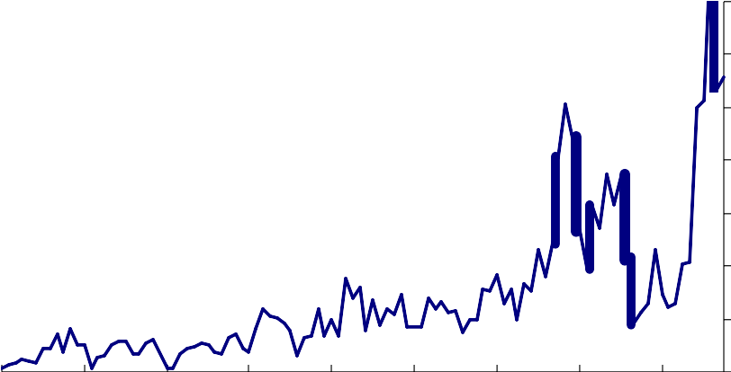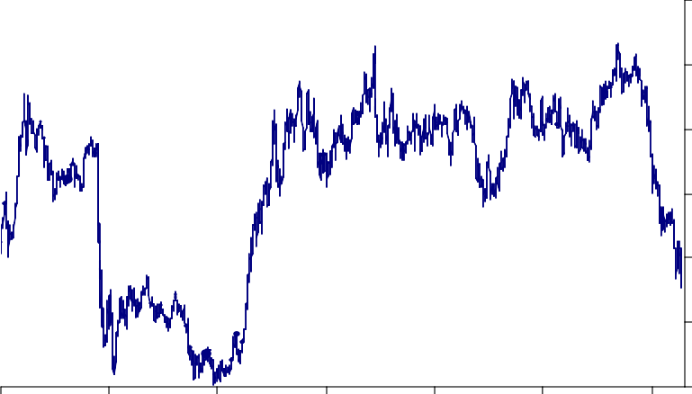

|  |  |  |  |  |
| --- | --- | --- | --- | --- |
| Chart 7: UK RMBS Issuance by all UK Resident Issuers | | | | |
|  |  |  |  | £ bn |
|  |  |  |  | 3-month rolling sum |
|  |  |  |  | 70 |
|  |  |  |  | 60 |
|  |  |  |  | 50 |
|  |  |  |  | 40 |
|  |  |  |  | 30 |
|  |  |  |  | 20 |
|  |  |  |  | 10 |
|  |  |  |  | 0 |
| 2000 2001 2002 2003 | 2004 | 2005 | 2006 | 2007 2008 |
| Source: Dealogic. Data to October 2008. |  |  |  |  |

|  |  |  |  |  |
| --- | --- | --- | --- | --- |
| Chart 8: Sterling ERI | | | | |
|  |  |  |  | Index, Jan 2005=100 |
|  |  |  |  | 110 |
|  |  |  |  | 105 |
|  |  |  |  | 100 |
|  |  |  |  | 95 |
|  |  |  |  | 90 |
|  |  |  |  | 85 |
|  |  |  |  | 80 |
| 1990 1993 | 1996 | 1999 | 2002 | 2005 2008 |
| Data to 23/10/2008 |  |  |  |  |

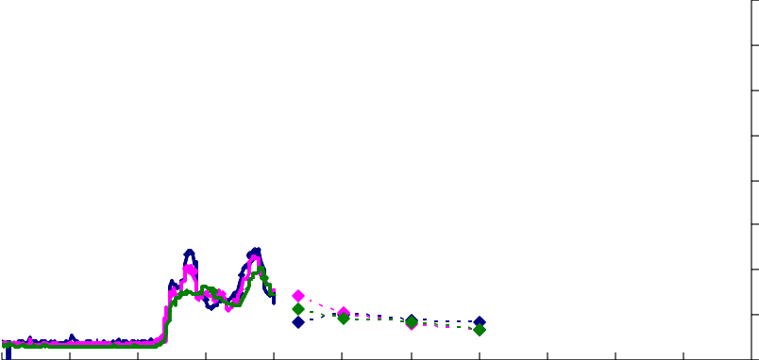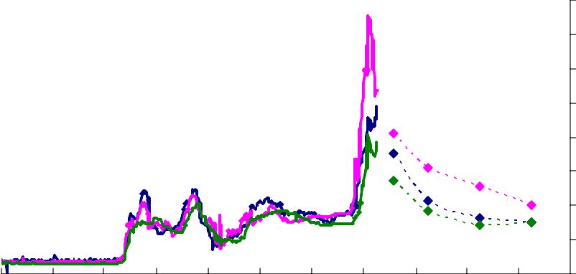

|  |  |  |  |  |  |  |
| --- | --- | --- | --- | --- | --- | --- |
| Chart 9: Libor-OIS Forward Spreads on 2 January 2008 | | | | | | |
| United Kingdom  United States Euro area  Jan Apr Jul Oct Jan  2007 08  Source: Bloomberg | Apr | Jul | Oct | Jan  09 | Apr | Basis points  390  340  290  240  190  140  90  40  -10  Jul |

|  |  |  |  |  |  |  |
| --- | --- | --- | --- | --- | --- | --- |
| Chart 10: Libor-OIS Forward Spreads on 24 October 2008 | | | | | | |
| United Kingdom  United States Euro area  Jan Apr Jul Oct Jan  2007 08  Source: Bloomberg | Apr | Jul | Oct | Jan  09 | Apr | Basis points  390  340  290  240  190  140  90  40  -10  Jul |

EFS households making mortgage payments (a)

ONS

Per Cent of Total

30

Chart 11: Housing expenditure

28

26

24

22

20

18

16

14

12

10

1974 1978 1982 1986 1990 1994 1998 2002 2006

1. Mean per capita

Sources: Expenditure and Food Survey, ONS and Bank calculations

ONS Housing Expenditure includes actual rents, imputed rents, maintenance and repair costs, water services, and energy.

EFS Housing Expenditure captures rent, mortgage payments, water and local rates, and insurance.

Per Cent

9

8

7

6

5

4

3

2

1

0

2008

1999 2000 2001 2002 2003 2004 2005 2006 2007

Average Bank and Building Societies Source: Bank of England

Discounted (75%)

Fixed (75% LTV)

Tracker (75% LTV)

SVR

Chart 12: Mortgage rates

|  |  |  |  |  |  |  |  |  |  |
| --- | --- | --- | --- | --- | --- | --- | --- | --- | --- |
| Chart 13: Housing Equity Withdrawal (quarterly flow) | | | | | | | | | |
|  |  |  |  |  |  |  |  | £bn |  |
|  |  |  |  |  |  |  |  |  | 20 |
|  |  |  |  |  |  |  |  |  | 15 |
|  |  |  |  |  |  |  |  |  | 10 |
|  |  |  |  |  |  |  |  |  | 5 |
|  |  |  |  |  |  |  |  |  | 0 |
|  |  |  |  |  |  |  |  |  | -5 |
| 1983 | 1986 | 1989 | 1992 | 1995 | 1998 | 2001 | 2004 | 2007 |  |